Leadership

Leadership is defined as influence, that is, the art or process of influencing people so that they will strive willingly and enthusiastically towards the achievement of group work.

Leadership can be summarized as personal quality of an individual that influence the behavior of followers. It is an important function of management. Leadership is an act of influencing people so that the followers follow the path of leader. The successful leader must lead to stimulate and inspire the followers to achieve organizational goals. In an organization the manager is a leader and other subordinates are followers. A manager cannot manage effectively unless he can lead his subordinates effectively. Hence a leader may or may not be a manager but a successful manager must be a leader.

**Difference between Leader and a Manager**

**1. Leaders create a vision, managers create goals:** Leaders paint a picture of what they see as possible and inspire and engage their people in turning that vision into reality. They think beyond what individuals do. They activate people to be part of something bigger. They know that high-functioning teams can accomplish a lot more working together than individuals working autonomously. Managers focus on setting, measuring and achieving goals. They control situations to reach or exceed their objectives.

**2. Leaders are change agents, managers maintain the status quo:** Leaders are proud disrupters. Innovation is their mantra. They embrace change and know that even if things are working, there could be a better way forward. And they understand and accept the fact that changes to the system often create waves. Managers stick with what works, refining systems, structures and processes to make them better.

**3. Leaders are unique, managers copy:** Leaders are willing to be themselves. They are self-aware and work actively to build their unique and differentiated personal brand. They are comfortable in their own shoes and willing to stand out. They’re authentic and transparent. Managers mimic the competencies and behaviors they learn from others and adopt their leadership style rather than defining it.

**4. Leaders take risks, managers control risk:** Leaders are willing to try new things even if they may fail miserably. They know that failure is often a step on the path to success. Managers work to minimize risk. They seek to avoid or control problems rather than embracing them.

**5. Leaders are in it for the long haul, managers think short-term:** Leaders have intentionality. They do what they say they are going to do and stay motivated toward a big, often very distant goal. They remain motivated without receiving regular rewards. Managers work on shorter-term goals, seeking more regular acknowledgment or accolades.

**6. Leaders grow personally, managers rely on existing, proven skills:** Leaders know if they aren’t learning something new every day, they aren’t standing still, they’re falling behind. They remain  curious and seek to remain relevant in an ever-changing world of work. They seek out people and information that will expand their thinking. Managers often double down on what made them successful, perfecting existing skills and adopting proven behaviors.

**7. Leaders build relationships, managers build systems and processes:** Leaders focus on people – all the stakeholders they need to influence in order to realize their vision. They know who their stakeholders are and spend most of their time with them. They build loyalty and trust by consistently delivering on their promise. Managers focus on the structures necessary to set and achieve goals. They focus on the analytical and ensure systems are in place to attain desired outcomes. They work with individuals and their goals and objectives.

**8. Leaders coach, managers direct:** Leaders know that people who work for them have the answers or are able to find them. They see their people as competent and are optimistic about their potential. They resist the temptation to tell their people what to do and how to do it. Managers assign tasks and provide guidance on how to accomplish them.

**9. Leaders create fans, managers have employees:** Leaders have people who go beyond following them; their followers become their raving fans and fervent promoters – helping them build their brand and achieve their goals. Their fans help them increase their visibility and credibility. Managers have staff who follow directions and seek to please the boss.

**Leadership Theories**

For a number of years, researchers have examined leadership to discover how successful leaders are created. Experts have proposed several theories, including the trait, behavioral, contingency models of leadership.

## The Trait Theory of Leadership

The search for the characteristics or traits of effective leaders has been central to the study of leadership. Underlying this research is the assumption that leadership capabilities are rooted in characteristics possessed by individuals. Research in the field of trait theory has shown significant positive relationships between effective leadership and personality traits such as intelligence, extroversion, conscientiousness, self-efficacy, and openness to experience. These findings also show that individuals emerge as leaders across a variety of situations and tasks.

## The Behavioral Theory of Leadership

In response to the early criticisms of the trait approach, theorists began to research leadership as a set of behaviors. Behavioral theories focus on the behavior of the leaders as opposed to their mental, physical or social characteristics as propounded by Trait Theory. Behavioral theorists evaluated what successful leaders did, developed a taxonomy of actions, and identified broad patterns that indicated different leadership styles. Thus researchers were able to measure the cause an effects relationship of specific human behavior from leaders. The theory promulgates that anyone with the right conditioning can become a leader and these qualities are not genetic.In other words, **leaders are made not born**.

The behavioral theories first divided leaders in two categories. Those that were concerned with the tasks and those concerned with the people. Throughout the literature these are referred to as different names, but the essence are identical.

## The Contingency Theory of Leadership

According to this approach, called contingency theory, no single psychological profile or set of enduring traits links directly to effective leadership. Instead, the interaction between those individual traits and the prevailing conditions is what creates effective leadership. In other words, contingency theory proposes that effective leadership is contingent on factors independent of an individual leader. As such, the theory predicts that effective leaders are those whose personal traits match the needs of the situation in which they find themselves. The Contingency Leadership theory argues that there is no single way of leading and that every leadership style should be based on certain situations, which signifies that there are certain people who perform at the maximum level in certain places; but at minimal performance when taken out of their element.

To a certain extent contingency leadership theories are an extension of the trait theory, in the sense that human traits are related to the situation in which the leaders exercise their leadership. It is generally accepted within the contingency theories that leader are more likely to express their leadership when they feel that their followers will be responsive.

**Leadership Styles**

**Autocratic leadership style**

When the authority and decision making power are concentrated to the leader it is known as autocratic leadership style. There is no participation by subordinates. The leader takes full authority and assumes full responsibility. Planning, policies and other working procedures are predetermined by the leader alone. The convey the information about what to do and how to do. They never take any advice or suggestions of other people. They structure the entire work situation in their own way and expect the workers to follow their orders and tolerate no deviation from their order. They are just like tyrant rulers. The leader who believes and exercises the autocratic leadership style is known as autocratic leader.

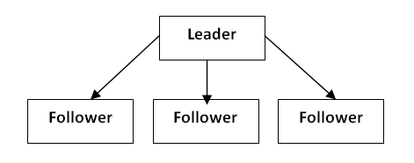

**Features**:

1. He/she makes his own decisions and he/she doesn’t not take any advice of others because he/she thinks he/she is only superior.
2. His/her position gives him/her personal authority and right to lead the members in any way he/she desires.
3. Reward and punishment is exercised by him/her very strictly. Autocratic leadership style believes on negative motivational tools.
4. An autocrat leader does not give full information to the members. There is only one way communication in order to maintain the position.
5. An autocratic leader describes each job in detail and imposes rigid work standard on his employees. It means the subordinates are compelled to certain work assigned for him.

**Advantages**:

1. It is useful in emergency or in war,
2. When the workers are undisciplined and uneducated it gives the best results.
3. When the laborers are not organized, it is more effective.
4. There is no need of trained labor. It may be used for untrained workers.
5. It is a prompt process of decision making as the single person decides for the whole group.

**Disadvantages**:

1. Subordinates are not involved in the process of decision making in autocratic leadership style
2. It doesn’t emphasize on correct evaluation of employee’s performance
3. The moral of employees is so low.
4. There is no chance of management development.
5. There is no chance of two-way communication.
6. Creative ideas and thinking cannot be used in autocratic leadership style.
7. The employees perform the work with negative motivation.

**Democratic leadership style:**

When the authority and decision making power are decentralized to the subordinates is known as democratic leadership style. There is participation by subordinates. The leader delegates authority and provides responsibility even to the followers. Planning, policies and other working procedures are determined by the leader along with suggestions of the followers. He conveys the information about what to do and how to do just as a consultant. He takes advice and suggestions of other people. They structure the entire work situation in democratic way. They are just like democratic rulers. The leader who believes and exercises the democratic leadership style is known as democratic leader.

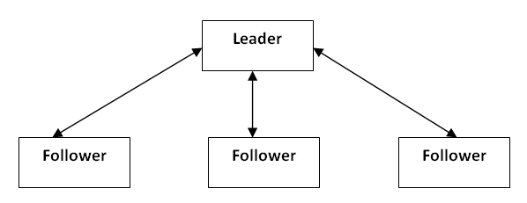

**Features**:

1. A democratic leader delegates the responsibility as per the capability of the employee
2. There is participation of all subordinates in decision making
3. Human values are also given preference. The leader gives concerns for the followers
4. Democratic leader imposes flexible work standard, designs goals with freedom for the performance of work.
5. A democratic leader emphasizes in results than on action

**Advantages**:

1. Good cooperation among employees is made in democratic leadership style.
2. Employees are highly satisfied and their morale is boosted
3. Efforts are recognized; employees are motivated
4. It helps in increasing in productivity.
5. Policies, planning and other working procedures become better because different kinds of logic, ideas and creativity are mixed
6. Subordinates have enjoy considerable freedom of action. It helps to increase the personal growth and gets opportunity to utilize their capabilities

**Disadvantages**:

1. It takes long time in decision making
2. It is not suitable for untrained subordinates
3. A leader may  to be responsible in his style
4. It is not suitable when the followers are undisciplined and untrained

**Free rein leadership style:**

When all the authority and responsibility are delegated to the subordinates is known as Free rein leadership style. The leader who believes on this style is known as free rein leader. The free rein leader doesn’t use the power and leaves the power to the subordinates. He/she doesn’t provide any contribution to make planning and policies. This type of leadership style is very useful when group members are intelligent and fully aware of their roles and responsibilities.

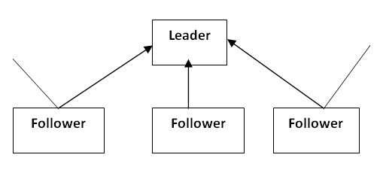

**Features:**

1. Subordinates have complete freedom in decision making
2. The subordinates are self-directed, self-motivated and self-controlled
3. The role of free rein leader is to provide facilities, materials and information to the employees.
4. The leader doesn’t interfere in making planning and policies

**Advantages**:

1. The employees are satisfied in their job because they are free in decision making
2. The morale of employees is developed.
3. The employees are highly developed because there is maximum possibility for the development of          workers.
4. The creativity and potentiality of subordinate are fully utilized.

**Disadvantages:**

1. Leader contribution is ignored.
2. Sometime the subordinates are not self-directed.
3. Subordinates should not get the guidelines of the leader.